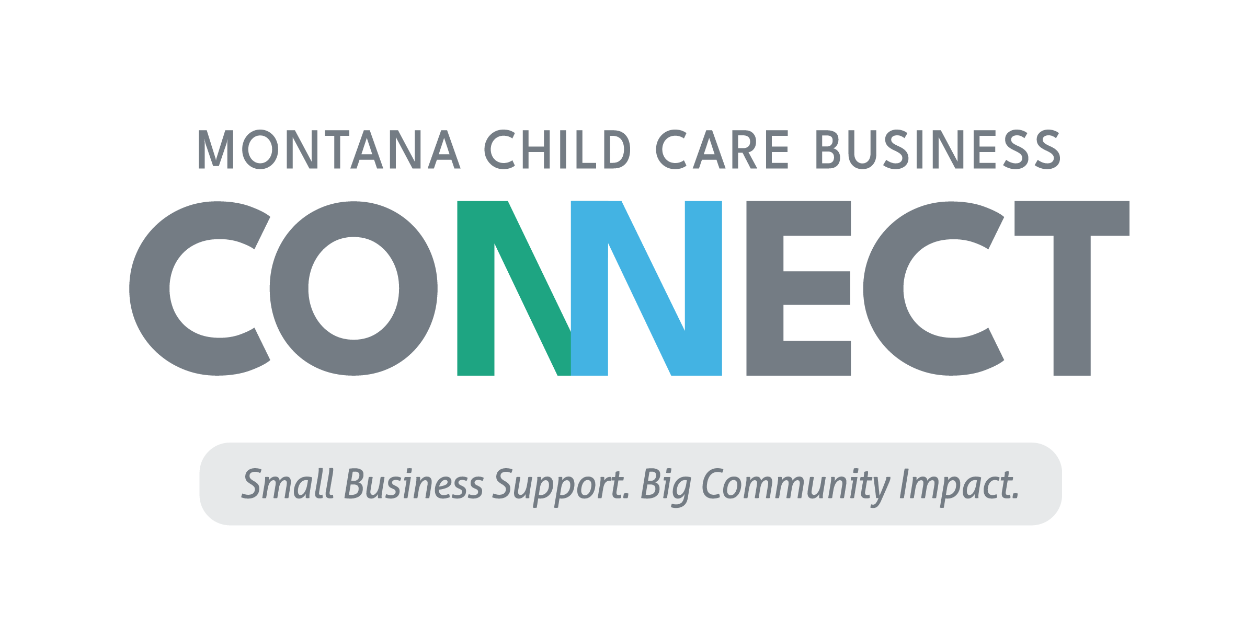
Loan Application Checklist

Every bank, credit union, and community lending organization has its own requirements for potential loan applicants seeking financing for a business. The following is a basic loan application checklist to assist you in gathering the basic information necessary to complete a loan application for business or commercial purposes.

EXISTING BUSINESS INFORMATION
❏ Internally prepared income statements and balance sheets for last 3 years (if applicable)
❏ Internally prepared income statements and balance sheets for the year, to date, through the most recent month (if applicable)
❏ Business tax returns for the last 3 years (if applicable)
❏ Affiliated business (if applicable)
❏ Business Tax returns for the last 3 years

LEGAL ENTITY DOCUMENTS (AS APPLICABLE)
❏ Entity Formation Documents
❏ Sole Proprietorship – Assumed Business Name filing
❏ Corporation – articles of Incorporation
❏ LLC – Articles of Organization
❏ Partnership – Partnership agreement
❏ Operating/partnership agreements
❏ Franchise agreement (if applicable)
❏ Licenses - Industry and jurisdictional (if applicable)
❏ Insurance – types and limits

PERSONAL INFORMATION (FOR EACH 20% OWNER)
❏ Personal tax returns for last 3 years
❏ Personal Financial Statements (SBA Form 413)
❏ Personal History Statements (SBA Form 912)
❏ Resumes of ownership and key employees
❏ Copy of driver’s licenses

PROJECT DOCUMENTS
❏ Copies of all project cost documents, including but not limited to:
❏ Buy/sell agreements, construction estimates, equipment quotes, working capital calculations, copies of notes to be refinanced, etc.

PLAN AND PROJECTIONS
❏ Business plan narrative illustrating how the idea will be executed
❏ Cash flow projections, projected income statements and balance sheets for three years
❏ Include at least one year by month to illustrate seasonality
❏ Detailed list of assumptions supporting the financial projections

