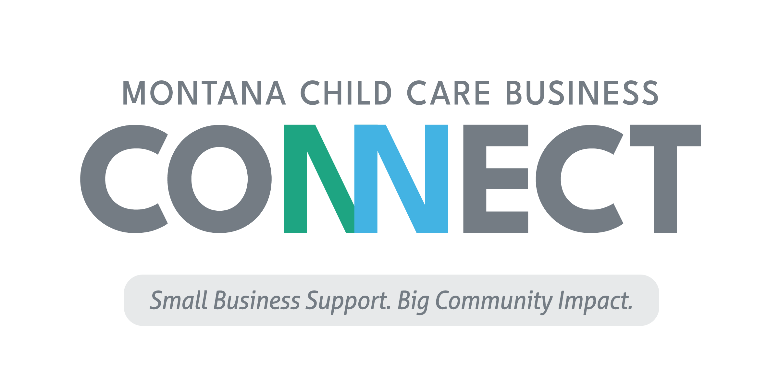
Childcare Business Startup Checklist

Starting a business can be exciting and frustrating. Most people who have never started a business ask the question, “Where do I start?” We recommend starting with the things that begin to separate the liability an entrepreneur will face by selling goods and services to the public from their personal assets.

There is a saying in the business world: “Liability always chases the biggest fish.” Protect yourself by separating yourself from the risks of doing business. Don’t comingle money. Get an insurance partner. And Google won’t defend you in a court of law so get your contracts, agreements, and waivers prepared by and/or reviewed by an attorney licensed to practice in the state of Montana.

The following is a list of best practices, presented in order of procedural importance.

LEGAL ENTITY CREATION AND LIABILITY SEPARATION
- Create the legal entity
- Get your Employer Identification Number
- Create a business bank account
- Secure a company credit card and/or line of credit.
  - Don’t comingle personal money with business money.
- General liability insurance policy for the business
  - The agent will likely ask for the assets owned by the business and the annual revenue of the company.
- Contracts, Agreements, and Waivers
  - Have these drafted or reviewed by an attorney licensed in Montana.

LICENSING
- Local business license (if required by your jurisdiction)
- Industry business license
  - Childcare providers apply for licensing with the Department of Health and Human Services.
- If you’ll be hiring employees, be sure to follow new hire requirements and get them set up for withholdings.
  - Montana Department of Revenue: Employee Tax
  - Montana Department of Labor & Industry: Employment Laws
  - Montana Department of Labor & Industry: Employer Resources
  - Montana Department of Public Health & Human Services: New Hire Booklet

SOFTWARE & MONEY MANAGEMENT
- Bookkeeping Software
  - Pick one that works for you. It will make tax reporting easier.
- Point of sale system
  - This could include student intake and registration and payment processing.
- Pricing structure
  - Do not set your price based on state reimbursement rates.
  - Pricing is an art. There are three ways to ensure your pricing is correct:
    - Cost-informed model
      - Cover all your fixed and variable costs, plus treat payment to ownership and payment of profit to the company as fixed costs.
    - Competition model
      - What’s the competition charging for the same product/service?
    - Market model
      - What are folks in this market willing to pay?

MARKETING ASSETS
- Target markets
  - Who, very specifically, are your customers? This is not ‘everyone.’
  - Develop a specific list of all the potential referral partners. Keep in mind, referral sources may not be the same as end users of your service.
- Value proposition
  - Figure out the best way to pitch your service and why a customer may be willing to pay for what you’re selling.
- Develop your brand
  - This is your name, logo, colors, etc.
- Invest in your initial marketing assets (things you use to promote yourself)
  - Email address
  - Business cards and fliers
  - Claim your Google My Business listing
  - Pick at least one social media platform to start with, whichever is easiest for you to display your portfolio.
  - Website
  - Professional photos to use in your promotional activities

These are just of few steps to take and there are other elements of owning and operating a business that should also be addressed. For additional assistance and next steps in the planning and launching of your childcare business, contact Zero to Five Montana’s Senior Child Care Business Advisor Jason Nitschke at JasonN@ZerotoFive.org.

###

